 |  |  | TCA LUNCH MENU |  |  |  | 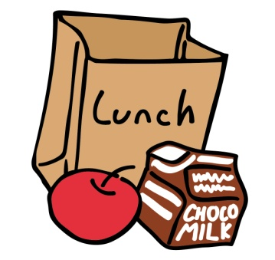
 |  |  |  |  |  | 2016-2017
To: Parents and Students
Below you will find a list of hot food items available, the day they are sold, and the cost per item.
The menu/cost may be subject to change.
Monday |  |  | Wendy’s: | Jr. Hamburger |  |  |  |  |  | $ 2.00
 |  |  |  | Jr. Bacon Cheeseburger |  |  |  |  |  | $ 2.00
 |  |  |  | Baked Potato |  |  |  |  |  | $ 2.00
 |  |  |  | Grilled Chicken Wrap |  |  |  |  |  | $ 2.00
 |  |  |  | Small Chili |  |  |  |  |  | $ 2.00
 |  |  |  | Chicken Nuggets |  |  |  |  |  | $ 2.00
 |  |  |  | Side Salad |  |  |  |  |  | $ 2.00
 |  |  |  | Crispy Chicken Sandwich |  |  |  |  |  | $ 2.00
 |  |  |  | Small Fries
Tuesday |  |  | Chicken Patty Sandwich/ Baby Carrots/ Ranch Dip |  |  |  |  |  |  | $ 2.50
 |  |  | Mozzarella Sticks (5)/ Baby Carrots/ Ranch Dip |  |  |  |  |  |  | $ 2.75
Wednesday |  |  | Pizza - cheese |  |  |  |  |  |  | $ 2.00
 |  |  | Pizza - pepperoni |  |  |  |  |  |  | $ 2.25
 |  |  | 1/2 Meatball sub w/cheese |  |  |  |  |  |  | $ 1.50
 |  |  | Meatball sub w/cheese |  |  |  |  |  |  | $ 2.50
Thursday |  |  | Chicken noodle soup |  |  |  |  |  |  | $ 1.50
 |  |  | Grilled cheese |  |  |  |  |  |  | $ 1.50
 |  |  | Roll |  |  |  |  |  |  | $ 0.50
Friday |  |  | Ziti w/Sauce or Butter |  |  |  |  |  |  | $ 2.00
 |  |  | Extra Sauce |  |  |  |  |  |  | $ 0.75
 |  |  | Buttered bread |  |  |  |  |  |  | $ 0.50
 | Miscellaneous:
 |  |  | Milk |  |  |  |  |  |  | $ 0.60
 |  |  | Juice Drinks/Bottled Water |  |  |  |  |  |  | $ 0.50
 |  |  | Iced Tea/Gatorade |  |  |  |  |  |  | $ 0.75
 |  |  | Ice Cream (assorted) |  |  |  |  |  |  | various

